DAVE ULRICH EXPLAINS THE ROLE OF THE HR BUSINESS PARTNER IN A DIGITAL AGE VIDEO:

https://www.youtube.com/watch?v=n_yfSJ151JQ

3 points of interest from the talk with Dave Ulrich
1. He believes he can't predict the future of where HR is going exactly, but believes that any job that involves assimilating and collecting information will be automated.
2. Talent has less of an impact on a company than how it is organised. -Very counterintuitive and not what I would have though at all.
3. Outsourcing of HR likely to falter in popularity. Instead it will be baked into organisations from the beginning, as opposed to tacked on later down the line.

David Ulrich on Bringing HR to the Table

https://www.youtube.com/watch?v=om-QOUNeWtM

Three Keys to Transforming HR
https://www.youtube.com/watch?v=V6y-9glrhqI

Overview of Ulrich’s Competency Model

https://www.youtube.com/watch?v=9BdjdgySzxE&list=PL8fZOI_bcsqmNssXBF9hqWejFlrc_QLfy&index=1

WHY OUTSOURCE IN HR?
https://www.youtube.com/watch?v=76NobD3dOIQ

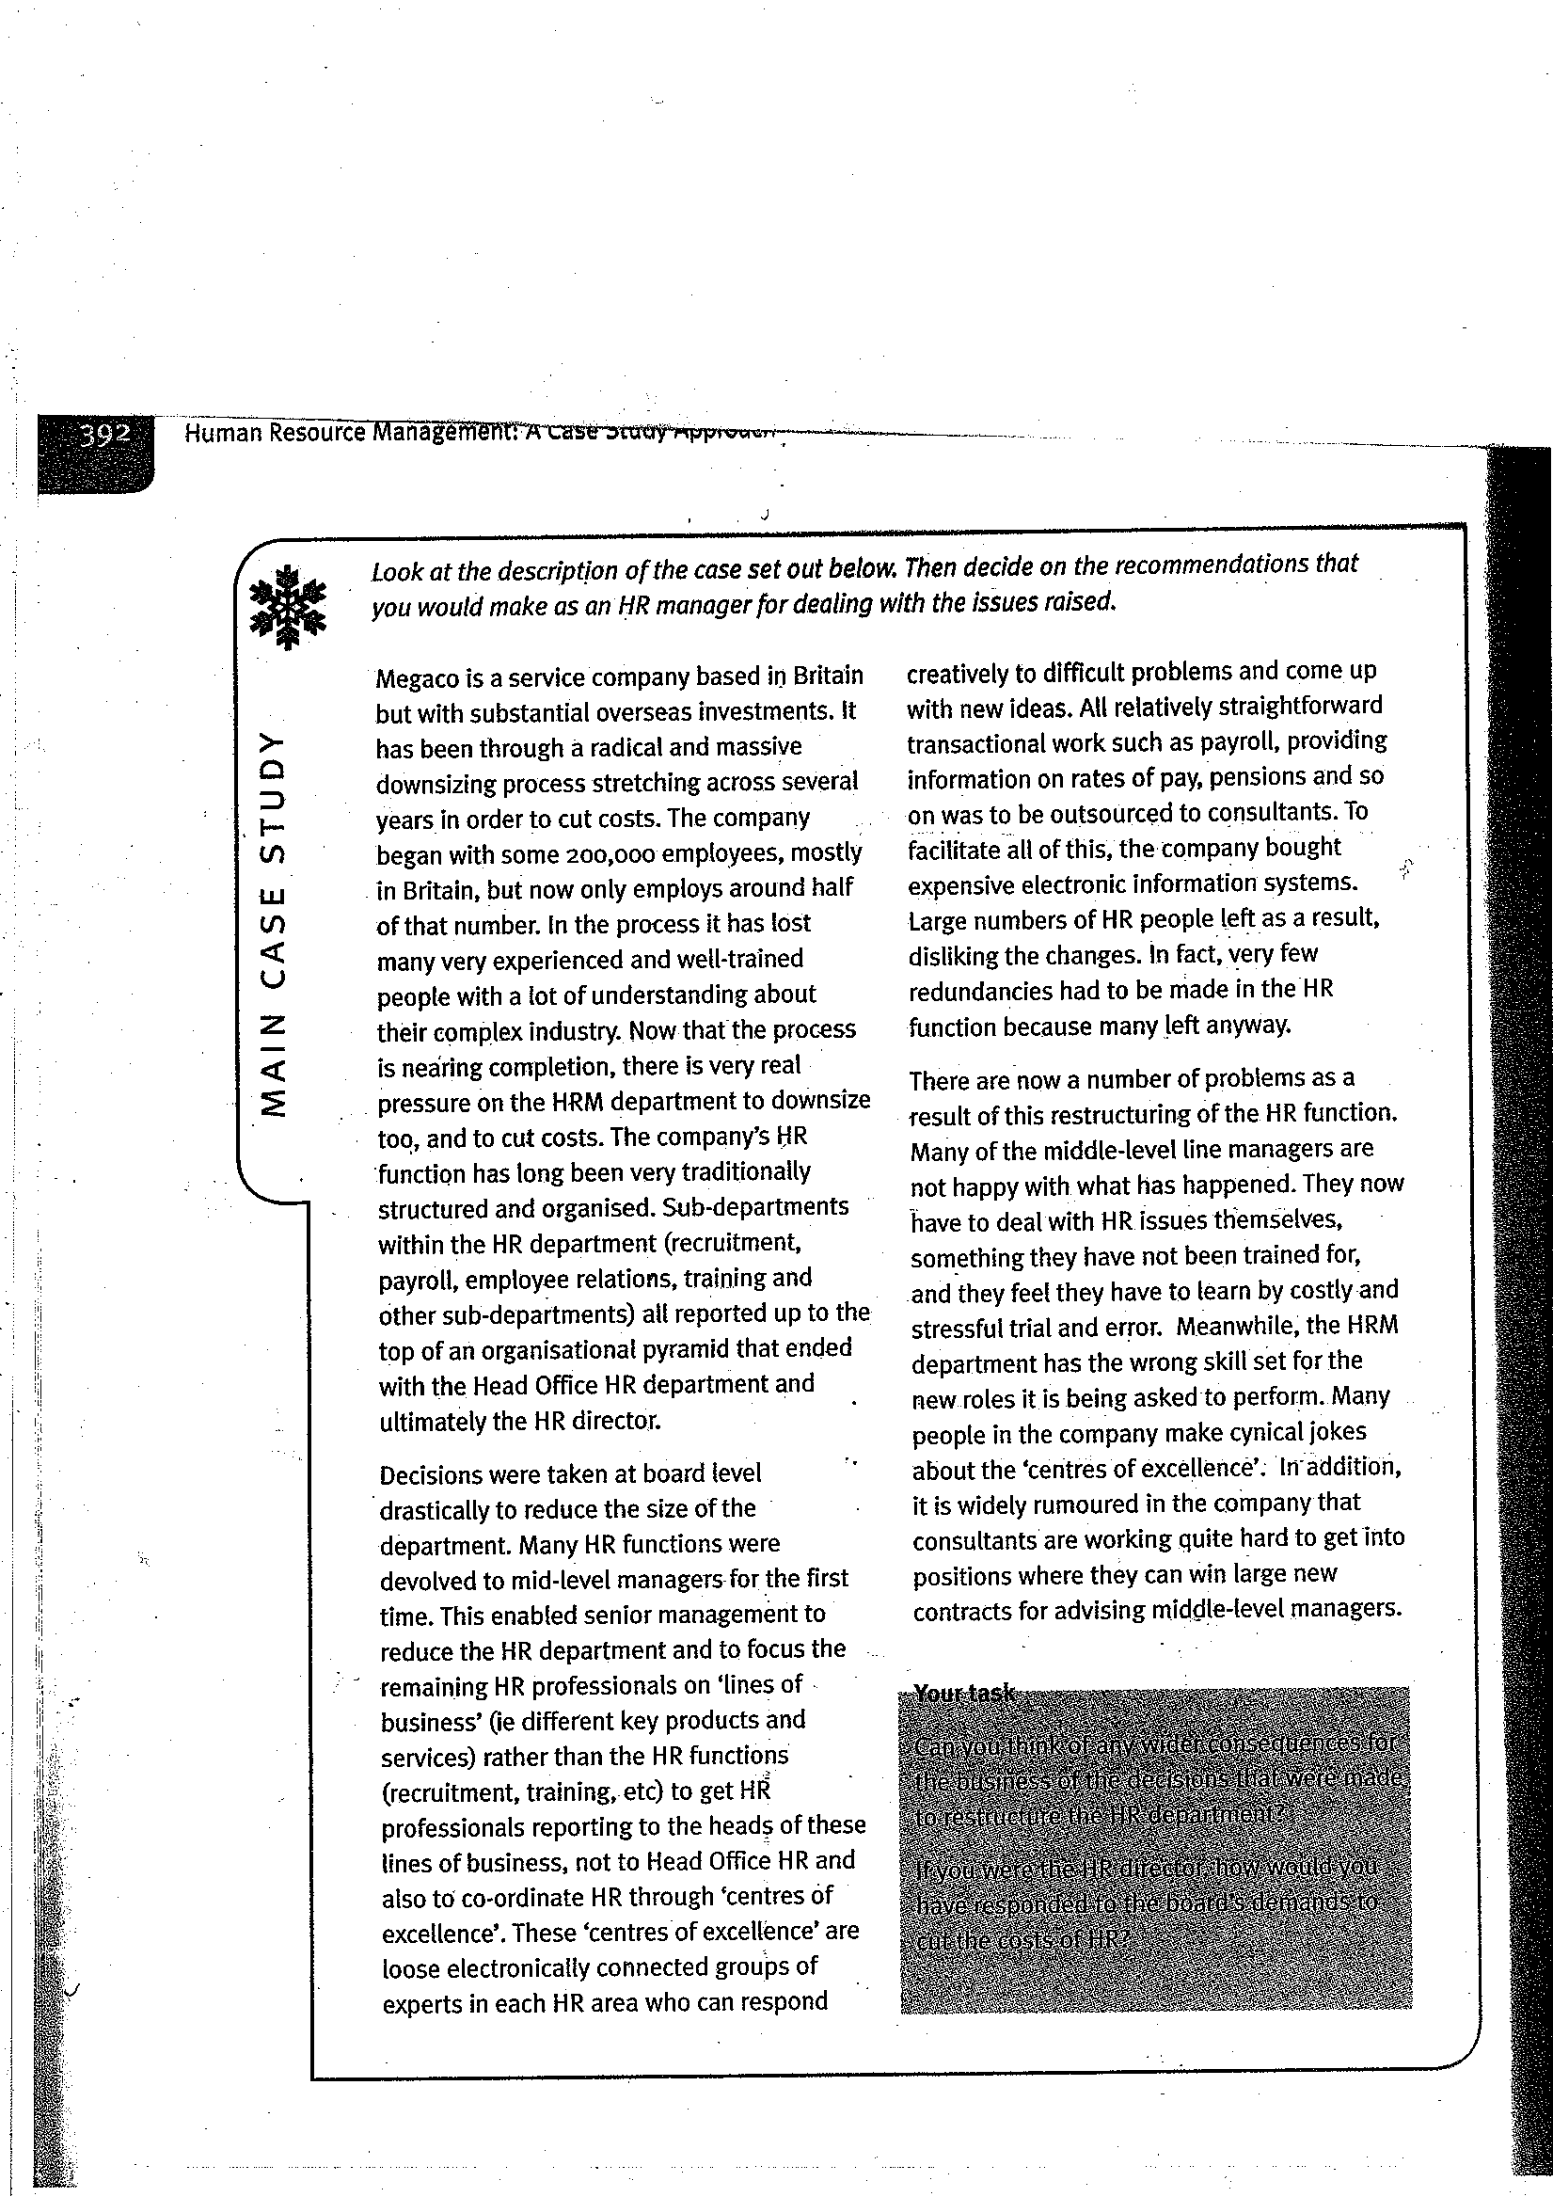

CASE STUDY AFTER ULRICH IMPLEMENTED

